

**Electric Energy Systems**

**EGE 351-01**

|  |  |  |
| --- | --- | --- |
| **Date: 05/04/2020                                               Semester: Spring 2020** | | |
| **Group Members** | **Department** | **Major Contribution** |
| **Caroline Kucher** | **EE** | **Theoretical calculations** |
| **Niki Fokas** | **EE** | **Simulations** |

**Instructor:  Dr. Gerald Selvaggi**

**Abstract**

In this project, by incorporating knowledge of circuit theory, electronics, and energy systems, a single phase input with an amplitude of 1V at 60 hz with a phase angle of was transformed into a three phase output with an amplitude of 7V with phase angles , , and .

**Table of Contents**

Objective……………………………………………………………………………...…………4

Theory………………………………………………………………………………………...…4

Theoretical Calculations………………………………………………………………………...7

Procedure…………………………………………………………………………………….….8

Schematics………………………………………………………………………….………….10

Simulations…………………………………………………………………………….....…13

Results…………………………………………………………………………………………16

Conclusion………………………………………………………………………………….….20

Works Cited……………………………………………………………………………………21

Bill of Materials……………………………………………………………………………......22

**Objective**

The goal of this project is to transfigure a single phase input into a balanced, three phase output while amplifying the output signal.

**Theory**

Three phase systems are polyphase systems with three different phases. A balanced three phase system is one that has three voltage sine waves which have the same magnitude and frequency (f) but are displaced from each other by 120° . In order to obtain a phase shift in a system, the theory of a simple resistor-capacitor circuit (RC circuit) can be used.

The combination of a resistor and capacitor in a circuit results in a phase shift that depends on the values of the resistance (R) and capacitance (C). The phase angle between resistance and capacitive reactance () is 90° and the phase angle for total impedance (Z) is somewhere between 0°and 90°.

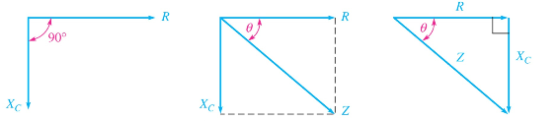

Figure 1: Impedance of a series RC circuit. [1]

Mathematically, these values can be found by,

(1)

(2)

(3)

In a series RC circuit, the current through all parts is the same in magnitude and phase. However, current through the resistor is in phase with the voltage across it but the current through the capacitor is 90° ahead of the voltage through it.Therefore, the voltages across R and C are out of phase.The voltage diagram of this RC circuit is shown below.

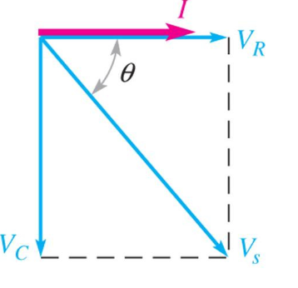

Figure 2: Voltage and current diagram for an RC circuit. [1]

In order for a total phase angle of 120° and 240°, the RC stages can be combined to obtain the required value. By voltage division, the voltage across the resistor can be found as:

(4)

This voltage across the resistor can be cascaded to acquire the desired phase angle.

Op-amps can be used to amplify a signal from losses due to the resistor in the RC circuit. A non-inverting op-amp can be used to compensate for this loss while not affecting the phase angle of the input. The gain of the non-inverting op-amp is:

(5)

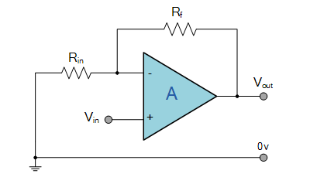

Figure 3: Non-inverting op-amp. [2]

The output voltage of the gain can be found as:

(6)

A power amplifier can be used to amplify the power of the load. A Class B CMOS push pull amplifier uses 2 transistors in a source follower configuration such that only one transistor is conducting at a time, greatly decreasing the quiescent current. This increases the efficiency from ~30% (Single Transistor Class A amplifier) to ~75% due to each transistor only having to conduct half the current going into the load. Because transistors are non-linear, signal distortion occurs at the crossover region. The crossover region is the point where one transistor turns off and the other turns on (when the sine wave goes through zero). An Op-Amp is used to provide negative feedback from the output to mitigate signal distortion at the crossover region (Figure 6, point VF1) as well as eliminate the need to bias the MOSFET. Ideally in the construction of this amplifier, matching transistors are used so that their parameters are identical. [3] [4]

**Theoretical Calculations**

The values of R and C have been chosen so that at the required frequency (60 hz) the voltage across the resistor is about .

ohms (1)

(3)

(4)

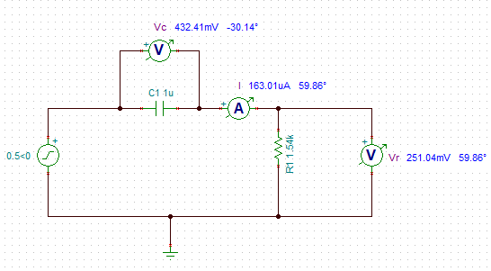

Figure 4: RC circuit with phase shift.

For the non-inverting op-amp, the gain and output voltage can be found as:

(5)

= 2.5V (6)

For the Class B output stage, Vin = Vout for resistive loads greater than or equal to 8 𝛀 due to the power supply being current limited to 0.5A. The output impedance for the source follower configuration is equal to RL||1/gm where gm=ID/VGS , RL = 100𝛀, and ID = IL/2.

**Procedure**

The first step in this project was the design and simulations. The RC circuits were designed and simulated to ensure a phase shift after each stage. Next, to compensate the voltage drop across the resistor, the LM358 non-inverting op-amp was included in the design and simulation. The three phase system would result by cascading the phase shift from the RC circuits. Each shift was then physically tested by inputting a signal and seeing the resulting phase angle from the output.This was then built on the breadboard and tested. At this point, it was realized that the power of this system was low. A power amp was then designed and simulated. Using a multifunction component tester, different p & n MOSFETS were measured until ones were found with Vt ,Rds, and Cg that were nearly identical, to ensure matching power MOSFETS. Then, the three power amplifiers were physically built and added into the three phase system.

**Schematics**

The following schematics were designed on Tina software.

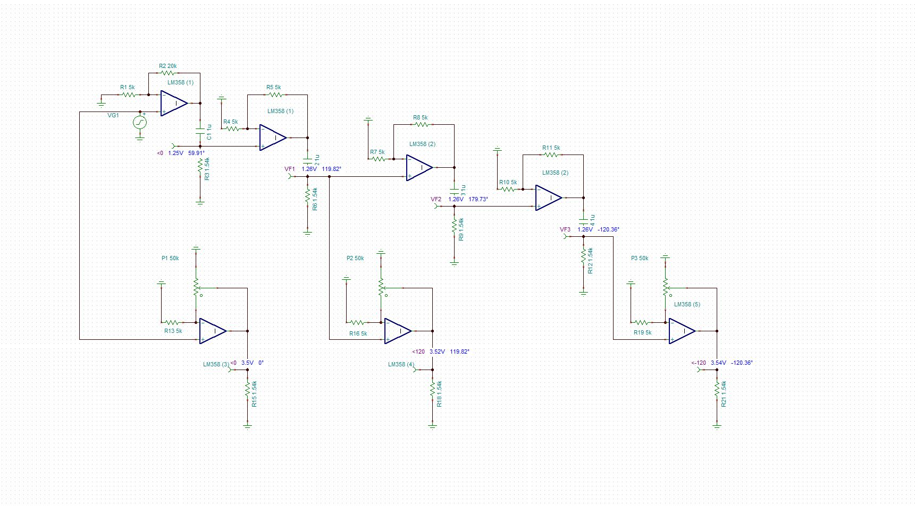

Figure 5: Single Phase to Three Phase.

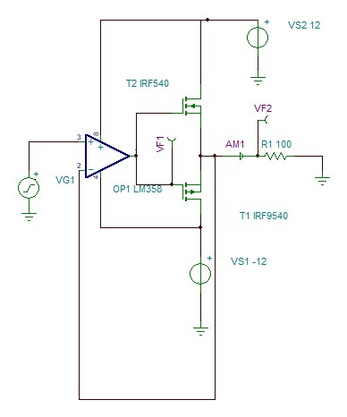

Figure 6: Class B CMOS Push Pull Power Amplifier with Feedback Output Stage.

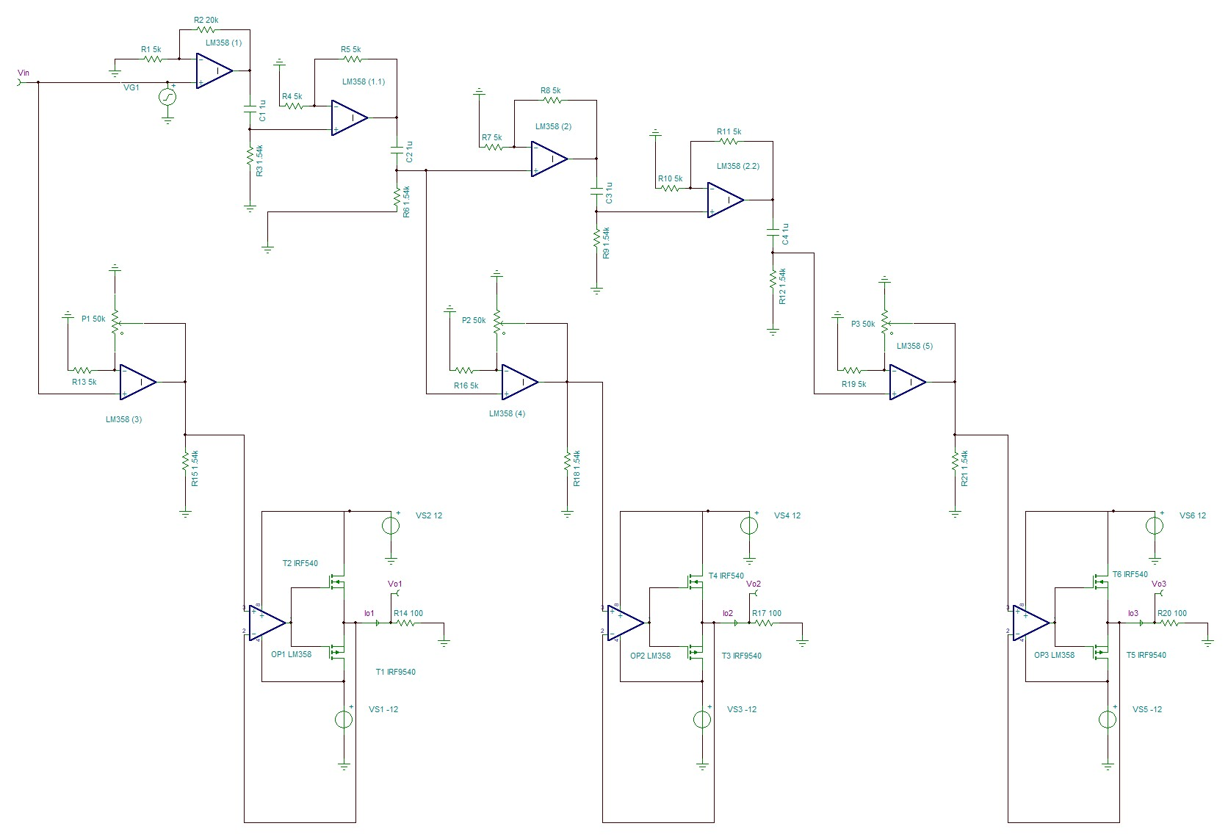

Figure 7: Single Phase to Three Phase with Power Amplifier.

**Simulations**

The following simulations were performed on Tina software.

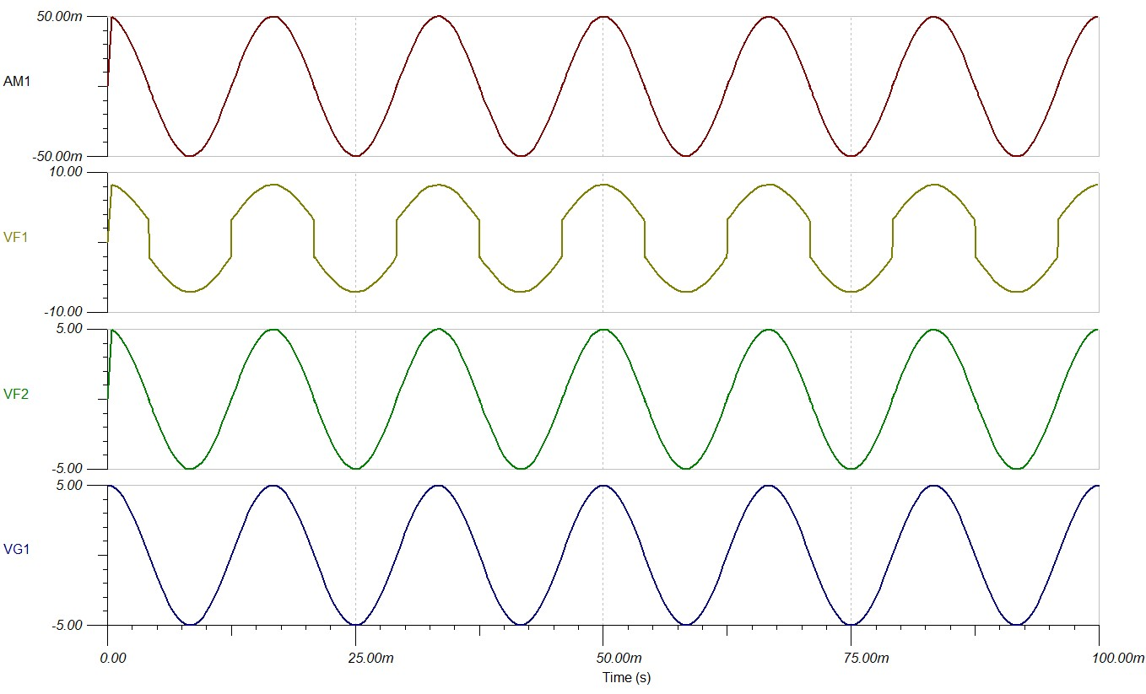

Figure 8: Power Amplifier Simulation.

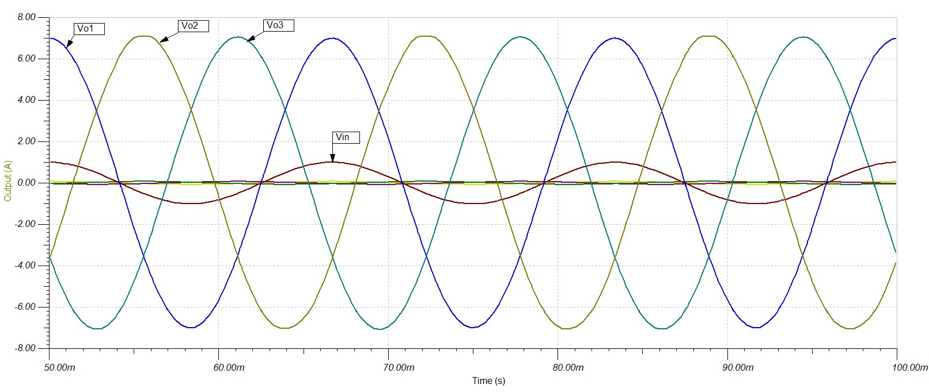

Figure 9: Single Phase to Three Phase with Power Amplifier.

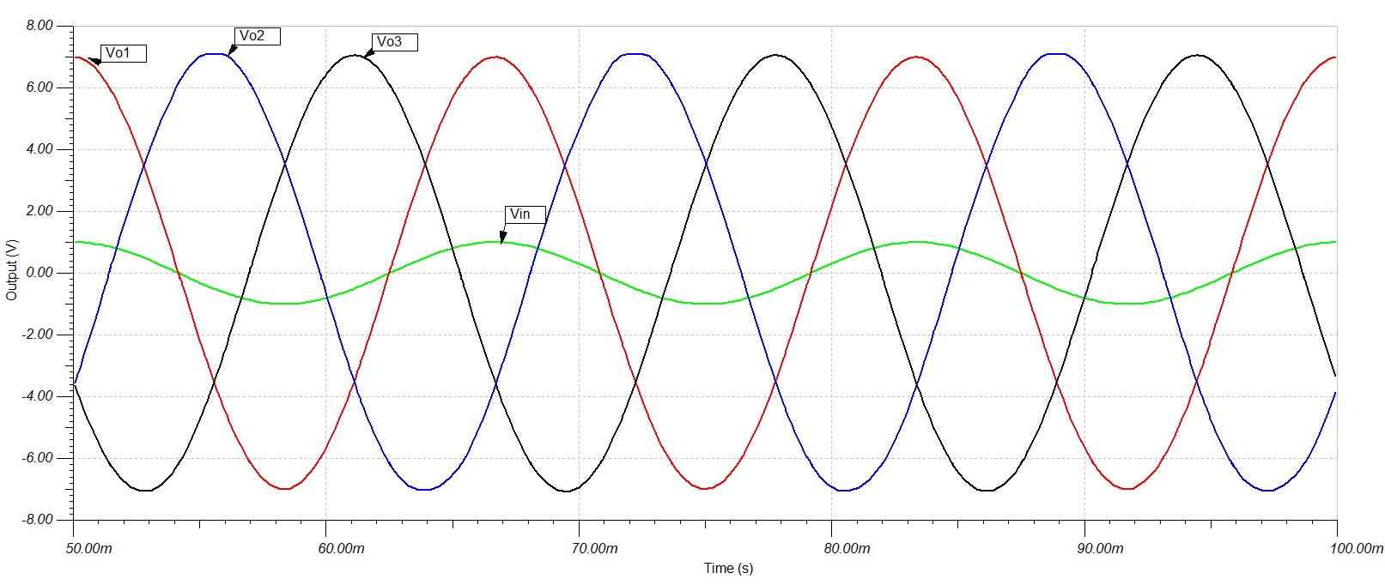

Figure 10: Output Voltages.

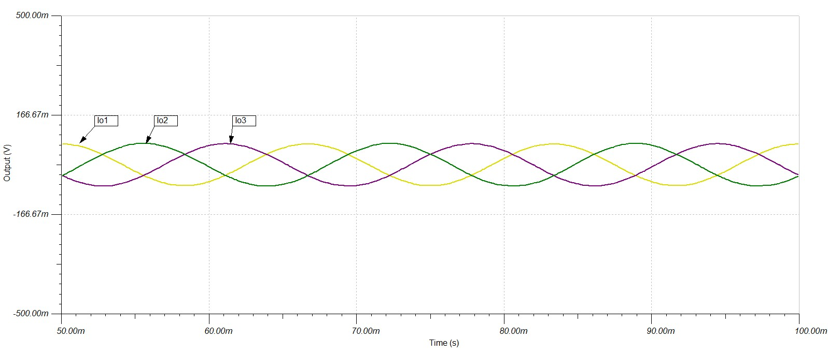

Figure 11: Output Currents.

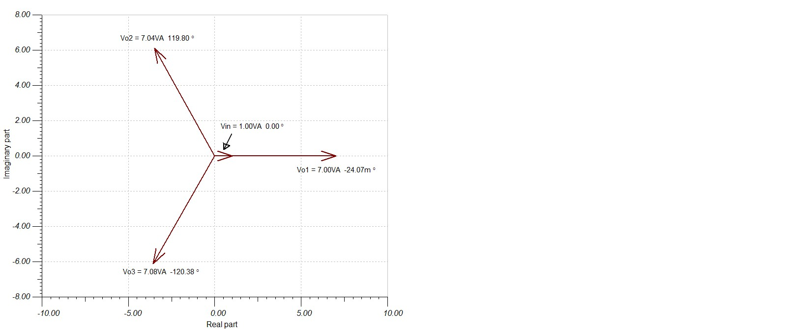

Figure 12: Phasor Diagram.

**Results**

The following figures and tables illustrate the results obtained for this project.

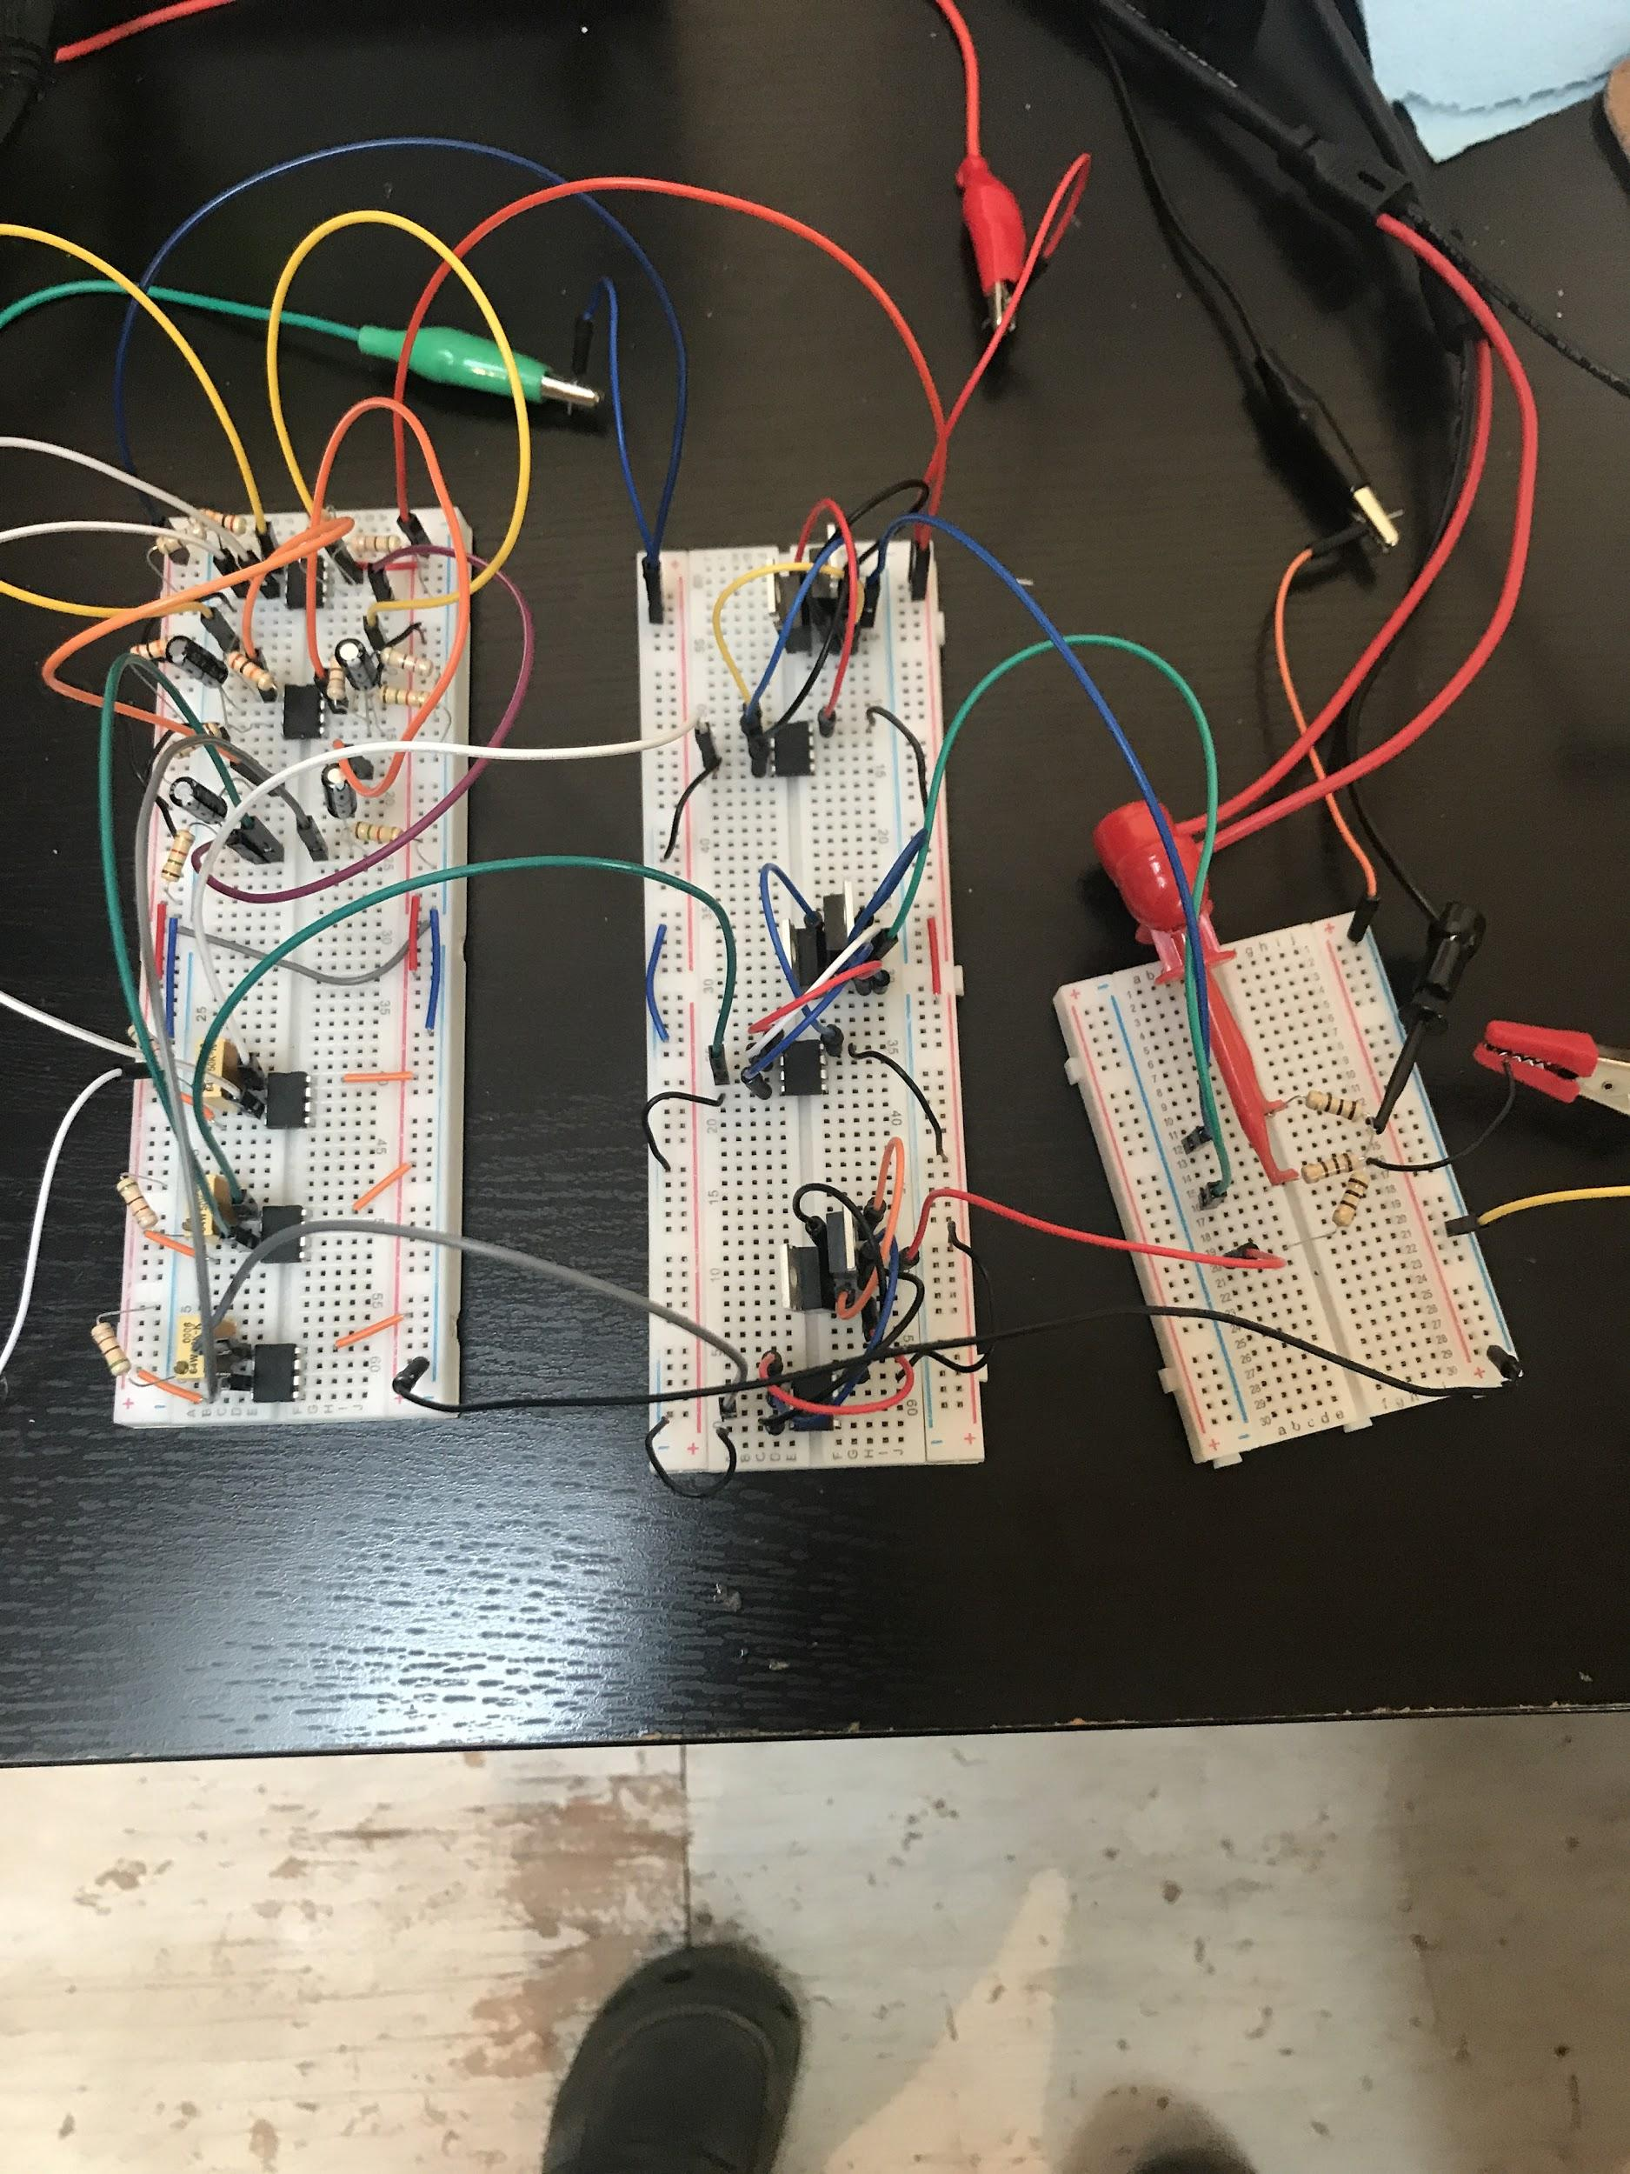

Figure 13: Single Phase to Three Phase with Power Amplifier connected to 100 ohm Y load.

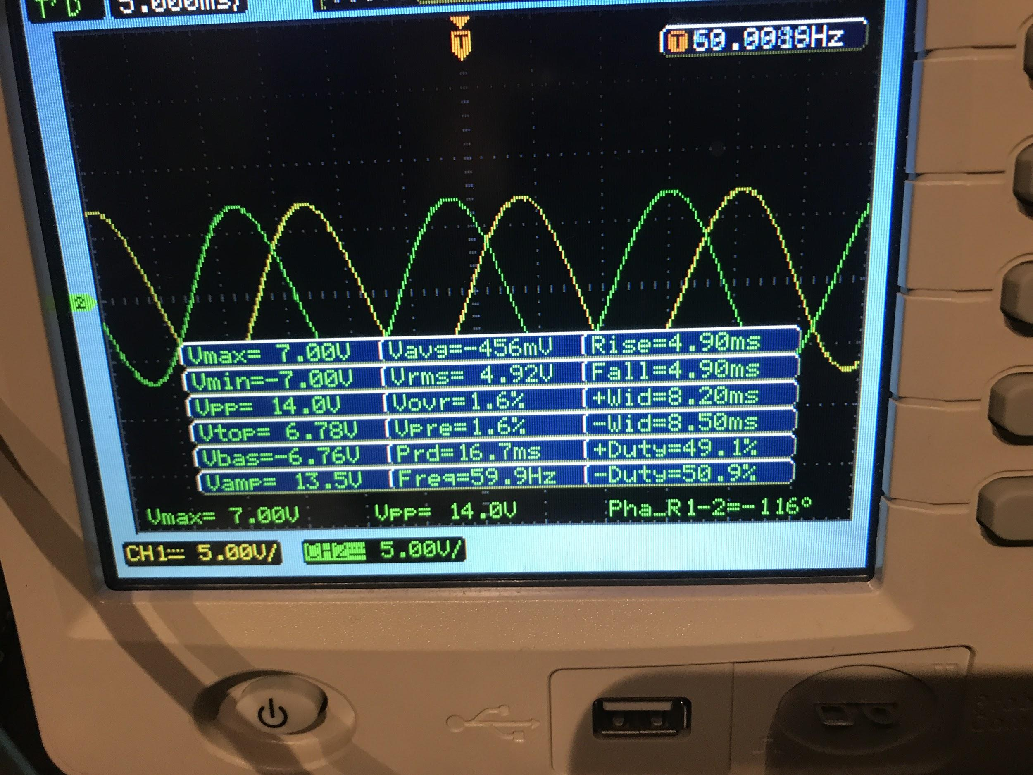

Figure 14: Phase 1(Yellow) & Phase 2 (Green).

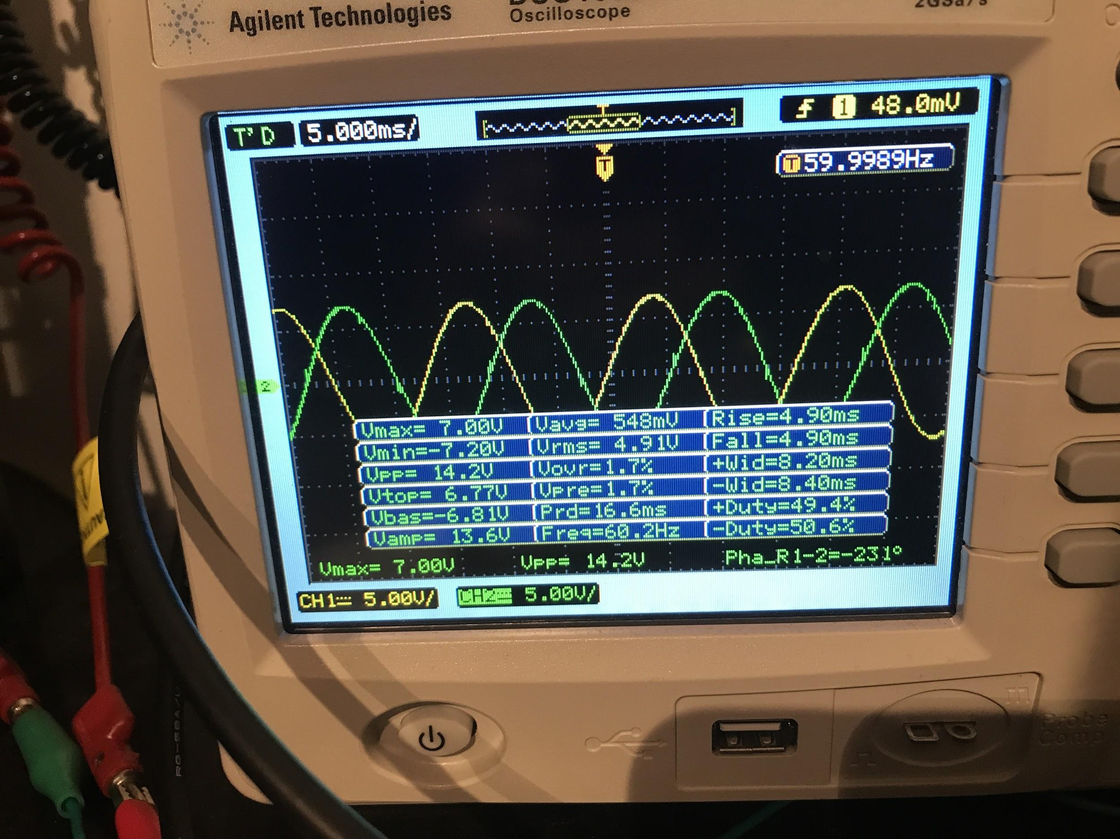

Figure 15: Phase 1 (Yellow) & Phase 3 (Green).

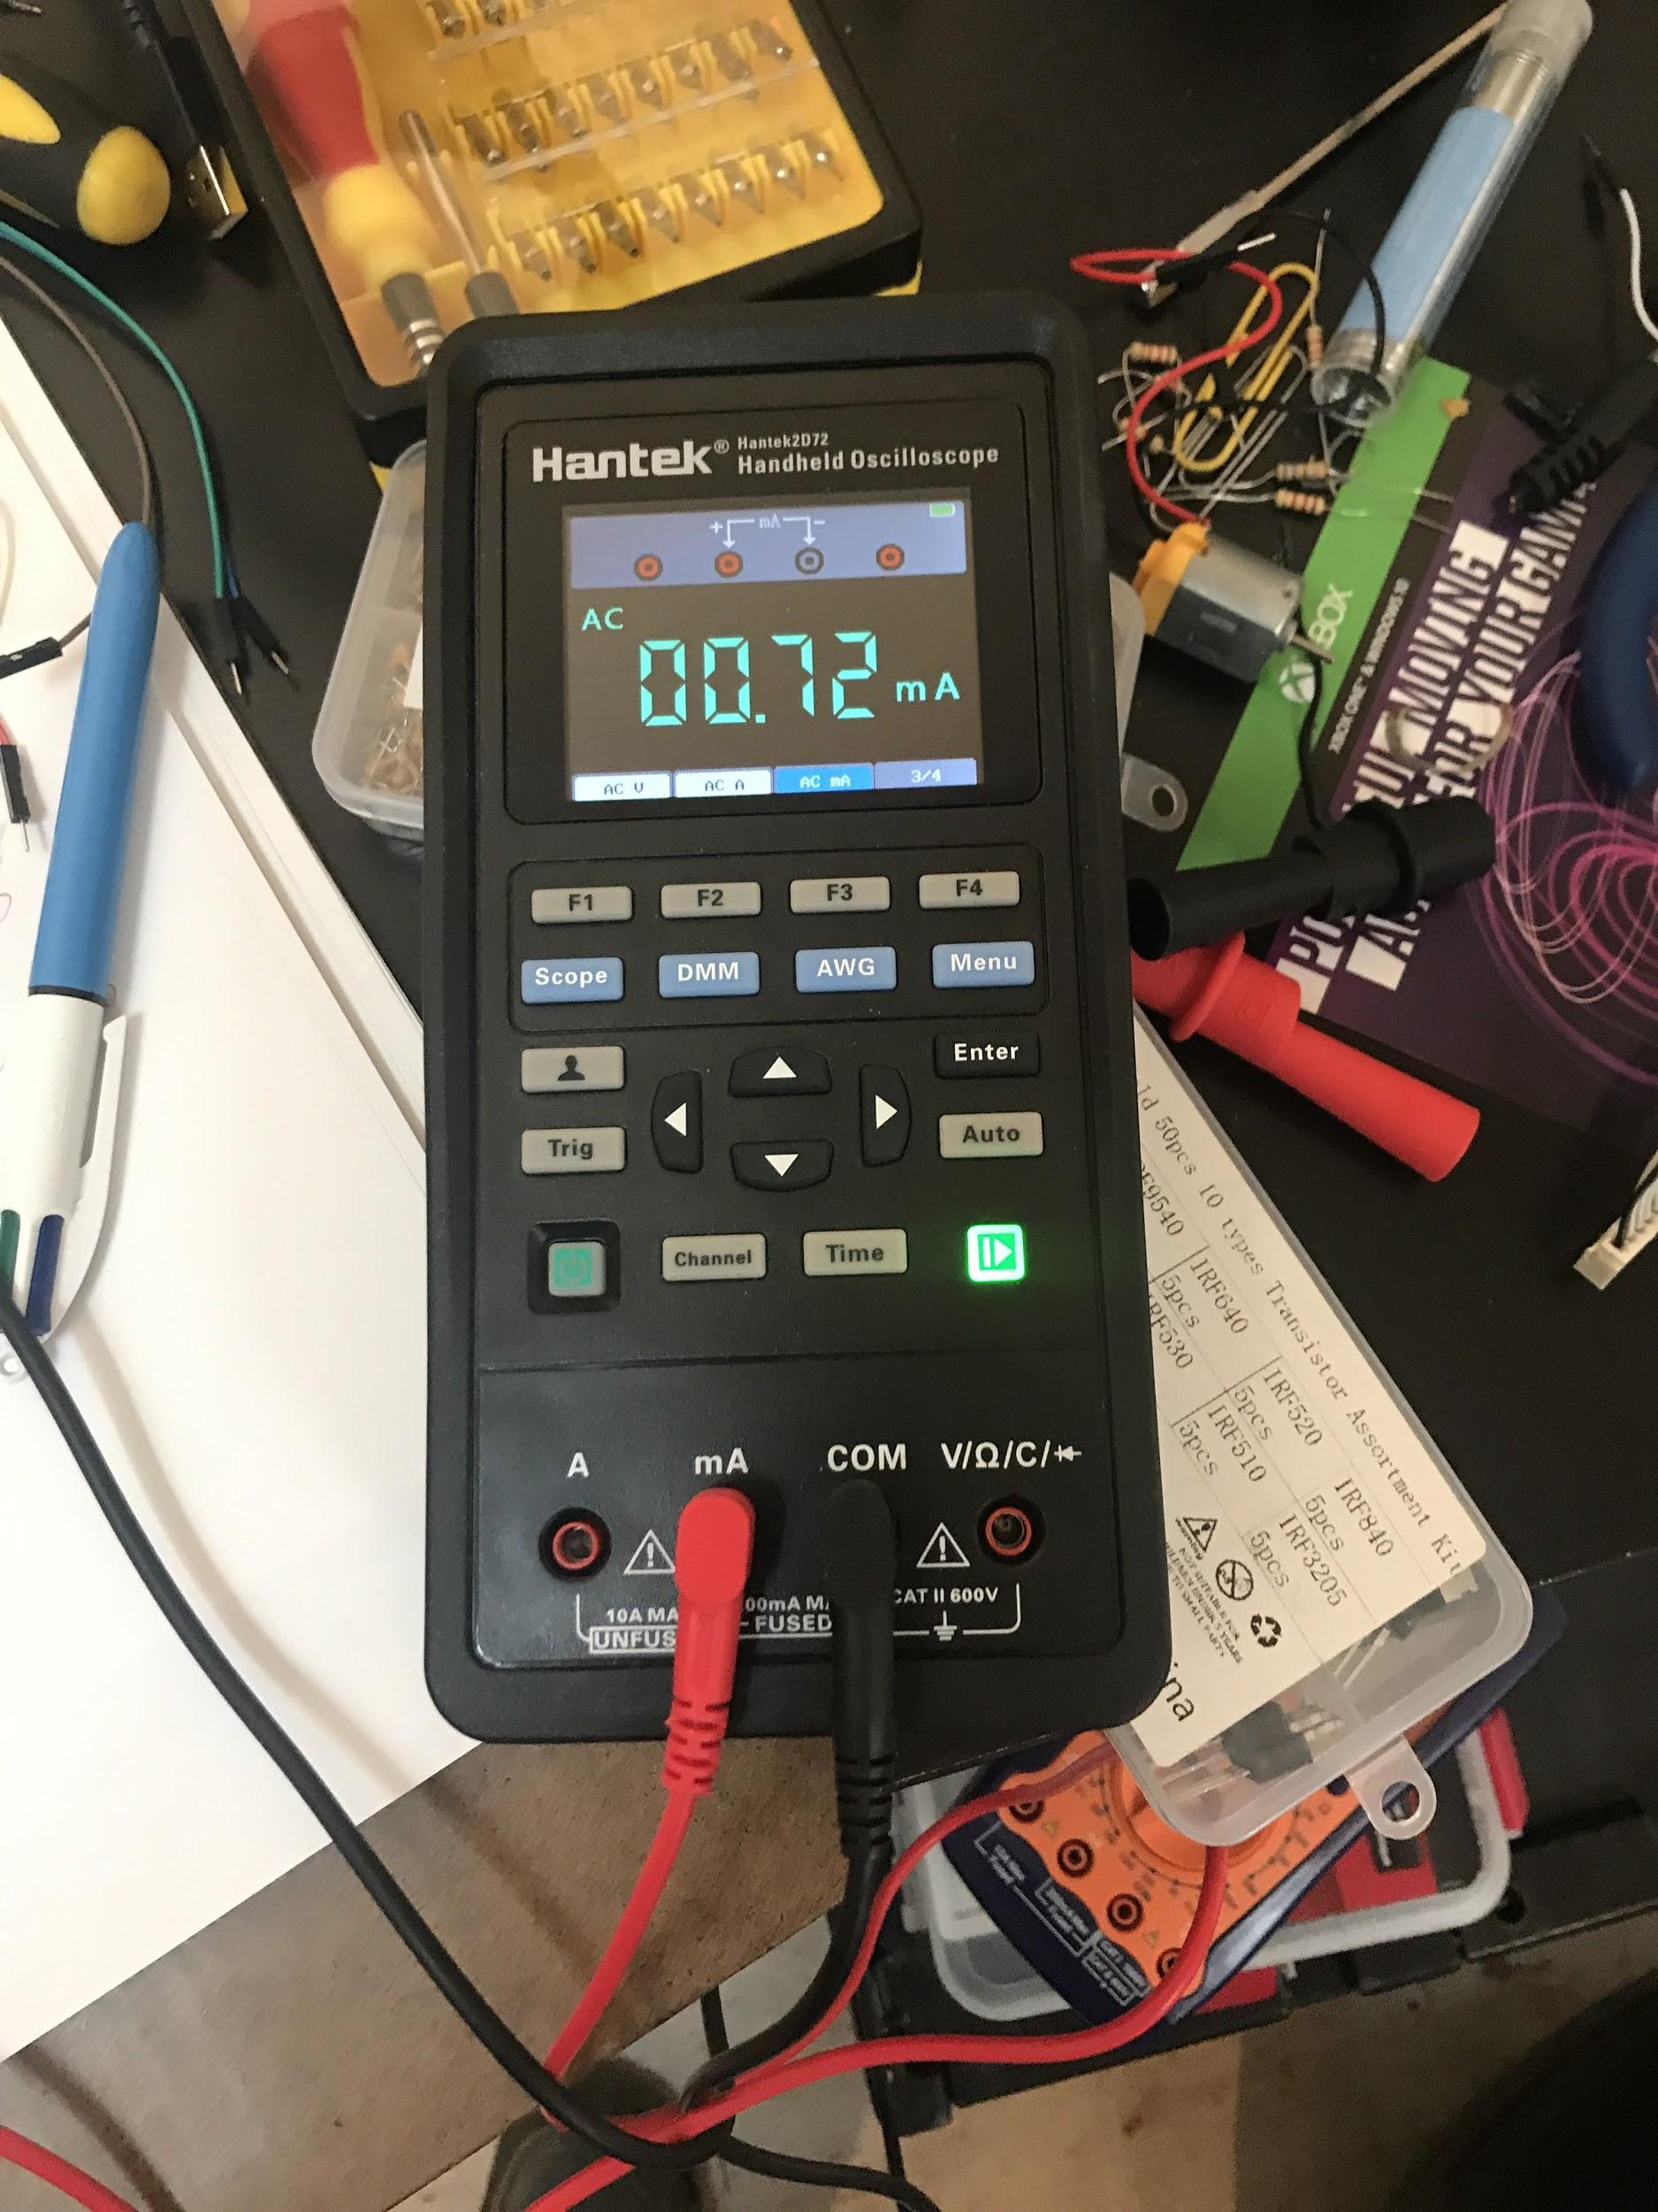

Figure 16: Neutral Current.

TABLE OF MEASURED MOSFET SPECIFICATIONS

|  |  |  |  |  |
| --- | --- | --- | --- | --- |
| n-mos | IRF540 | vt | cg (nF) | rds(on) |
|  | 1 | 1.78 | 1.38 | 0.2 |
|  | 2 | 1.78 | 1.83 | 0.2 |
|  | 3 | 1.78 | 1.82 | 0.4 |
|  |  |  |  |  |
| p-mos | IRF9540 | vt | cg nF | rds(on) |
|  | 1 | 2.07 | 1.43 | ~0 |
|  | 2 | 2.07 | 1.42 | ~0 |
|  | 3 | 2.07 | 1.42 | ~0 |

Table 1. MOSFET data.

TABLE OF EXPERIMENTAL DATA

|  |  |  |  |  |  |  |  |
| --- | --- | --- | --- | --- | --- | --- | --- |
|  | Voltage (V) | Current (mA) | Phase Angle | Power (W) | Voltage Gain V/V | Current Gain A/A | Power Gain W/W |
| Phase 1 | 7 | 70 | 0 | 0.49 | 7 | 933333.3333 | 6533333.333 |
| Phase 2 | 7 | 70 | -116 | 0.49 | 7 | 933333.3333 | 6533333.333 |
| Phase 3 | 7 | 70 | -231 | 0.49 | 7 | 933333.3333 | 6533333.333 |
| Neutral | N/A | 0.72 | N/A | N/A | N/A | N/A | N/A |
| Vin | 1 | 75 nA | 0 | 0.000000075 | N/A | N/A | N/A |

Table 2. Results.

Line Current to Neutral Current Ratio = 97.2

**Conclusion**

This project was successful as a single phase input was converted into a balanced, three phase output with a significant power gain. Additionally, this project served as a great hands-on learning experience that involved numerous aspects of Electrical Engineering.

A future design improvement would be to include an active low pass filter the three phase output in order to filter out higher order harmonics.

**Works Cited**

[1] T. Floyd, “RC Circuits.” [Online]. Available: http://eon.sdsu.edu/~johnston/EE204_PDF_Slides/Chapters 8-10/CH10.pdf. [Accessed: 14-May-2020].

[2] “Non-inverting Operational Amplifier - The Non-inverting Op-amp,” *Basic Electronics Tutorials*, 24-Feb-2018. [Online]. Available: https://www.electronics-tutorials.ws/opamp/opamp_3.html. [Accessed: 15-May-2020].

[3] Maurice Yunik Design of Modern Transistor Circuits, Prentice-Hall 1973 ISBN 0-13-201285-5 pp. 340-353

[4] Donald G. Fink, ed. Electronics Engineer's Handbook, McGraw Hill 1975 ISBN 978-0-07-020980-0 pp. 13-23 through 13-24

**Bill of Materials**

|  |  |  |  |  |
| --- | --- | --- | --- | --- |
| # | Quantity | Label | Value | Footprint |
| 1 | 1 | C1 | 1u | CP_CYL300_D700_L1400 |
| 2 | 1 | C2 | 1u | CP_CYL300_D700_L1400 |
| 3 | 1 | C3 | 1u | CP_CYL300_D700_L1400 |
| 4 | 1 | C4 | 1u | CP_CYL300_D700_L1400 |
| 5 | 1 | Io1 |  | Amet |
| 6 | 1 | Io2 |  | Amet |
| 7 | 1 | Io3 |  | Amet |
| 8 | 1 | LM358 (1) |  |  |
| 9 | 1 | LM358 (1.1) |  |  |
| 10 | 1 | LM358 (2) |  |  |
| 11 | 1 | LM358 (2.2) |  |  |
| 12 | 1 | LM358 (3) |  |  |
| 13 | 1 | LM358 (4) |  |  |
| 14 | 1 | LM358 (5) |  |  |
| 15 | 1 | OP1 | LM358 | DIP8 |
| 16 | 1 | OP2 | LM358 | DIP8 |
| 17 | 1 | OP3 | LM358 | DIP8 |
| 18 | 1 | P1 | 50k | potmeter |
| 19 | 1 | P2 | 50k | potmeter |
| 20 | 1 | P3 | 50k | potmeter |
| 21 | 1 | R1 | 5k | R_AX600_W200 |
| 22 | 1 | R2 | 20k | R_AX600_W200 |
| 23 | 1 | R3 | 1.54k | R_AX600_W200 |
| 24 | 1 | R4 | 5k | R_AX600_W200 |
| 25 | 1 | R5 | 5k | R_AX600_W200 |
| 26 | 1 | R6 | 1.54k | R_AX600_W200 |
| 27 | 1 | R7 | 5k | R_AX600_W200 |
| 28 | 1 | R8 | 5k | R_AX600_W200 |
| 29 | 1 | R9 | 1.54k | R_AX600_W200 |
| 30 | 1 | R10 | 5k | R_AX600_W200 |
| 31 | 1 | R11 | 5k | R_AX600_W200 |
| 32 | 1 | R12 | 1.54k | R_AX600_W200 |
| 33 | 1 | R13 | 5k | R_AX600_W200 |
| 34 | 1 | R14 | 100 | R_AX600_W200 |
| 35 | 1 | R15 | 1.54k | R_AX600_W200 |
| 36 | 1 | R16 | 5k | R_AX600_W200 |
| 37 | 1 | R17 | 100 | R_AX600_W200 |
| 38 | 1 | R18 | 1.54k | R_AX600_W200 |
| 39 | 1 | R19 | 5k | R_AX600_W200 |
| 40 | 1 | R20 | 100 | R_AX600_W200 |
| 41 | 1 | R21 | 1.54k | R_AX600_W200 |
| 42 | 1 | T1 | IRF9540 | TO220AB |
| 43 | 1 | T2 | IRF540 | TO220AB |
| 44 | 1 | T3 | IRF9540 | TO220AB |
| 45 | 1 | T4 | IRF540 | TO220AB |
| 46 | 1 | T5 | IRF9540 | TO220AB |
| 47 | 1 | T6 | IRF540 | TO220AB |
| 48 | 1 | VG1 |  | Sgen |
| 49 | 1 | VS1 | -12 | JP100 |
| 50 | 1 | VS2 | 12 | JP100 |
| 51 | 1 | VS3 | -12 | JP100 |
| 52 | 1 | VS4 | 12 | JP100 |
| 53 | 1 | VS5 | -12 | JP100 |
| 54 | 1 | VS6 | 12 | JP100 |